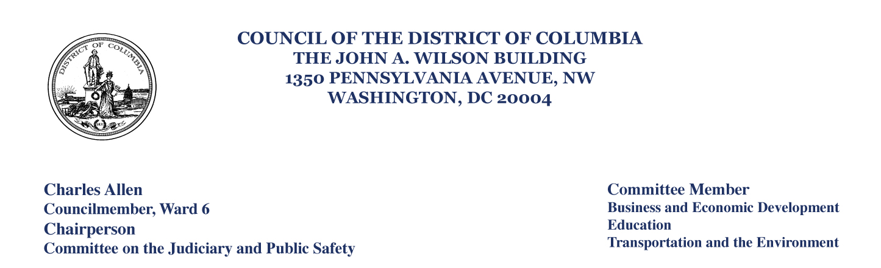

September 28, 2020

Mr. David Valenstein
Office of Railroad Policy and Development
USDOT Federal Railroad Administration (MS-20 RPD-10)
1200 New Jersey Avenue, SE
Washington, DC 20590

Dear Mr. Valenstein,

I am writing to submit my comments on the Draft Environmental Impact Statement (“DEIS”) for the Washington Union Station Expansion Project. In addition to my comments in this letter, I request that the Federal Railway Administration incorporates the comments in D.C. Council PR23-936, the Sense of the Council Regarding the Union Station Expansion Project Resolution of 2020. I represent Ward 6 on the Council of the District of Columbia, which includes Union Station, and I also serve as First Vice Chair of the National Capital Region Transportation Planning Board. My perspective on this project is both hyper-local and regional. From both of those perspectives, I have been shocked that the planning for one of the busiest transit hubs in the region continues to be so short-sighted. I hope that as this project moves forward, it will reflect input from local leaders; right now, it does not.

The Union Station Expansion Project is a once in a century opportunity. This project can ensure that Union Station remains a nationally significant landmark, showcasing excellence in urban planning and design while also knitting the project into the fabric of the community. This project can also ensure that Union Station is a model 21st (and perhaps even 22nd) century local and regional transportation hub. I am very supportive of the elements that enhance and substantially expand the train capacity at Union Station, as well as the reorientation of the train hall, and believe it shows a commitment to attracting and accommodating the expected growth in rail passengers with a well-lit, welcoming environment inside the station. But the Federal Railway Administration’s (“FRA”) preferred alternative, in particular the urban planning elements, including a massive garage and ill-considered circulation plan, poses a threat that will miss the opportunity before us and serve to isolate the station rather than integrate it within the surrounding community, businesses, and planned development. The direction of the current plan would be a costly investment in infrastructure that undermines rather than enhances the District of Columbia’s efforts to increase economic vitality, livability, and urban experience. I have three particular concerns.

First, while I appreciate that the preferred alternative does contemplate fewer parking spaces than in the current garage, I believe parking must be even further reduced at this dense, urban transit hub. The preferred alternative includes nearly 1,600 parking spaces in a large above-ground parking structure. A National Capital Planning Commission report on the project notes that 1,390 of the 2,200 parking spots currently in the Union Station parking garage are used by monthly parkers—generally, neither retail customers at Union Station nor rail passengers. In this light, 1,575 parking spaces in the preferred alternative are nearly double the approximately 800 parking spots currently dedicated to actual Union Station uses. The District of Columbia’s Office of Planning recommends less than 300 parking spaces—in line with planning goals for the District at large that seek to avoid inducing additional demand for single-occupancy vehicles. While reports note that 70% of revenue for the Union Station Redevelopment Corporation (“USRC”), which oversees the station, comes from parking, that alone is not enough reason to ignore planning trends and projections from the District of Columbia’s own planning body. USRC performs essential functions for Union Station, and all parties are invested in its continued success, but we should not assume that USRC’s business model cannot change.

Second, any design going forward must create a Union Station that is better integrated into the rest of the neighborhood and serves the place-making role that this national gateway to the District of Columbia represents. In this respect, I take seriously the concerns raised in the past by Advisory Neighborhood Commission (“ANC”) 6C, which directly represents Union Station’s neighbors. In a letter to Mayor Muriel Bowser and D.C. Council Chairman Phil Mendelson, ANC 6C noted “grave concerns that the interest of community members . . . are being given short shrift in the planning process[,]” and that “[a]s currently envisioned, the expanded Union Station would be surrounded by a snarl of cars and buses, creating a barrier to access for the residents of the surrounding neighborhoods.” While ANC 6C has nominally been part of the process, there have been no changes to the design that would suggest FRA has taken seriously the commissioners’ comments on design; that must change going forward. Additionally, the District has budgeted more than $200 million to rebuild H Street, N.E.—currently a bridge that isolates Union Station from the neighborhood north of H Street—to allow for better pedestrian connections across H Street. The design for Union Station must consider the planned reconstruction of H Street and the planned private development that adjoins the federal site. Doing anything less will lead to design decisions that isolate the station, damage the District’s long-term interests in Union Station’s potential, and create substantial harm that cannot be easily reversed in the future.

Third, providing underground bus slips and passenger pick-up-and-drop-off zones will be essential to reducing traffic congestion and ensuring that the new Union Station is integrated into the rest of the neighborhood. With the proliferation of transportation network companies (“TNC”), especially in urban areas, thoughtful planning for pick-up-and-drop-off zones is essential at major transportation hubs like Union Station. Good planning that allows for TNC vehicles that drop off to make immediate pick-ups could even help to reduce total trips in and out of the new Union Station. Further, the above-ground space at Union Station is a prime opportunity to provide retail and restaurants in a dense neighborhood, and it should not be wasted on bus and TNC pick-ups and drop-offs that can more easily be done underground.
The Union Station expansion and related projects are an exciting opportunity to produce a vital and nationally significant transportation center with great public spaces on par with those of any world class city. I ask that FRA recognize the moment before us, with shared goals and expectations, and demonstrate a course correction in the design, to better shape this historic and monumental investment that will determine Union Station’s vital and necessary role for generations to come.

Thank you for your consideration of this matter. If you have any additional questions, please feel free to contact me or my Chief of Staff, Laura Marks.

Sincerely,


Councilmember Charles Allen, Ward 6
Chair, Committee on the Judiciary and Public Safety

cc: Chairman Phil Mendelson, Chair, Committee of the Whole
Councilmember Mary M. Cheh, Chair, Committee on Transportation and Environment
Director Jeff Marootian, District of Columbia Department of Transportation
Director Andrew Trueblood, District of Columbia Office of Planning
Advisory Neighborhood Commissioner Karen Wirt, Chair, Advisory Neighborhood Commission 6C

